South Sudan

## GNI per capita and development level

The data set shows the GNI per capita and development level of the country each year.

## # A tibble: 19 x 5  
## country iso3c date GNIperCapita devCategory   
## <chr> <chr> <dbl> <dbl> <chr>   
## 1 South Sudan SSD 1996 511. Low Income   
## 2 South Sudan SSD 1998 351. Low Income   
## 3 South Sudan SSD 2000 280. Low Income   
## 4 South Sudan SSD 2002 229. Low Income   
## 5 South Sudan SSD 2003 339. Low Income   
## 6 South Sudan SSD 2004 37872. High Income   
## 7 South Sudan SSD 2005 346. Low Income   
## 8 South Sudan SSD 2006 479. Low Income   
## 9 South Sudan SSD 2007 598. Low Income   
## 10 South Sudan SSD 2008 614. Low Income   
## 11 South Sudan SSD 2009 608. Low Income   
## 12 South Sudan SSD 2010 457. Low Income   
## 13 South Sudan SSD 2011 681. Low Income   
## 14 South Sudan SSD 2012 3229. Lower Middle Income  
## 15 South Sudan SSD 2013 691. Low Income   
## 16 South Sudan SSD 2014 689. Low Income   
## 17 South Sudan SSD 2015 693. Low Income   
## 18 South Sudan SSD 2016 713. Low Income   
## 19 South Sudan SSD 2017 555. Low Income

## GDP growth and economic growth classification

The data set shows the GDP growth and the ecomic growth classification of the country each year.

## # A tibble: 19 x 5  
## country iso3c date GDPannualGrowthRate GDPgrowthCategory4  
## <chr> <chr> <dbl> <dbl> <fct>   
## 1 South Sudan SSD 1996 3.64 moderate growth   
## 2 South Sudan SSD 1998 3.81 moderate growth   
## 3 South Sudan SSD 2000 0.121 slow growth   
## 4 South Sudan SSD 2002 0.121 slow growth   
## 5 South Sudan SSD 2003 8.83 fast growth   
## 6 South Sudan SSD 2004 8.49 fast growth   
## 7 South Sudan SSD 2005 3.00 moderate growth   
## 8 South Sudan SSD 2006 3.00 moderate growth   
## 9 South Sudan SSD 2007 3.00 moderate growth   
## 10 South Sudan SSD 2008 1.77 slow growth   
## 11 South Sudan SSD 2009 5.04 moderate growth   
## 12 South Sudan SSD 2010 5.49 moderate growth   
## 13 South Sudan SSD 2011 -4.64 negative grwoth   
## 14 South Sudan SSD 2012 -46.1 negative grwoth   
## 15 South Sudan SSD 2013 13.1 fast growth   
## 16 South Sudan SSD 2014 3.37 moderate growth   
## 17 South Sudan SSD 2015 -10.8 negative grwoth   
## 18 South Sudan SSD 2016 3.37 moderate growth   
## 19 South Sudan SSD 2017 3.37 moderate growth

## Development trend

The plot shows the development trend of the country.

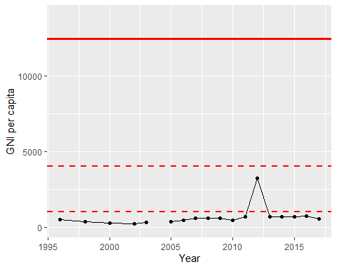

GNI Per Capita Trend